KHWOPA SECONDARY SCHOOL
DEPARTMENT OF COMPUTER SCIENCE
Dekocha-06, BHAKTAPUR

A FINAL REPORT
ON
“E Commerce”
A Report Submitted for the partial fulfilment of requirement for the degree of NEB
in Computer Science
Submitted by: Submitted To:
Prajan KC (521) Department of Computer Alex Shrestha (707) Khwopa Secondary School
Dekocha-06, Bhaktapur

UNDER THE GUIDANCE OF
Er. Jamin Rai

Date of submission: 2082/ / /
DEPARTMENT OF COMPUTER SCIENCE
KHWOPA SECONDARY SCHOOL
DEKOCHA-06, BHAKTAPUR

CERITFICATE
This is to certify that the project entitled “E Commerce” submitted by Mr Prajan KC, Mr Alex Shrestha in a partial fulfillment of the requirements for the internal marks of Computer science in NEB (National Education Board) Class 12 (XII), is a bonafide work to the best of my/our knowledge and may be placed before the examination board for their consideration.

Name Signature Date
Jamin Rai

ACKNOWLEDGEMENT
We are thankful to all those who have helped us directly or indirectly with this project. Foremost, we would like to thank the Department of Computer Science of Khwopa Secondary School for the giving an opportunity to carry out project entitled "E Commerce". We would like to thank our computer teachers Jamin Rai for their guidance while developing project and also for organizing the project schedules. Also we would like to acknowledge their effort that encouraged us to take this challenging project. We would also like to offer our gratitude towards some of our friends who helped throughout our project development phase by providing several references and making project work.

ABSTRACT
The rapid growth of digital technology has increased the demand for online shopping platforms. This lab report presents the design and development of an e-commerce website for fashionable clothes. The website provides users with an easy and efficient way to browse, select, and purchase trendy clothing online. It includes essential features such as product catalog, detailed product view, shopping cart, and checkout system. The system is designed with a user-friendly interface to enhance customer experience and improve accessibility. This project demonstrates the application of web technologies in developing an online fashion store and highlights the importance of e-commerce in modern retail business.

Table of Contents

CERITFICATE ii
ACKNOWLEDGEMENT iii
ABSTRACT iv
1. Introduction 1
2. Objectives 2
3. Problem Statement 3
4. Software & Hardware Requirements 4
5. System Description 5
6 Description 6
6.1 Home Page 6
6.2 Product Catalog 6
6.3 Product Details Page 6
6.4 Shopping Cart 6
6.5 Checkout & Payment 6
7. Methodology 7
Sample Code Snippet (HTML) 7
7.1 Advantages 7
7.2 Applications 7
7.3 Limitations 8
7.4 Future Enhancements 8
Result 9
CONCLUSION 11
APPENDIX 12

Introduction
Design and Development of an E-Commerce Website for Fashionable Clothes. E-commerce involves buying and selling products or services online. It has transformed how businesses and customers interact, making transactions faster and easier. This presentation will explore the fundamental concepts and types of e-commerce, helping students understand its role in the modern world.

Objectives
- To understand the working of an e-commerce system
- To design a user-friendly interface for fashion products
- To implement product listing, cart, and checkout features
- To provide a secure and efficient online shopping experience

Problem Statement
Traditional shopping is time-consuming and limited by location. There is a need for an online platform where customers can easily browse and purchase fashionable clothes anytime and anywhere.

Software & Hardware Requirements

4.1 Hardware
- Computer/Laptop
- Minimum 4 GB RAM
- Internet Connection
4.2 Software
- Operating System: Windows / Linux / macOS
- Frontend: HTML, CSS, JavaScript
- Backend: PHP / Node.js (optional)
- Database: MySQL (optional)
- Web Browser: Chrome / Firefox

System Description
5.1 The e-commerce fashion website provides an online platform for users to:
- View fashionable clothing collections
- Search and filter products by category, price, or size
- Add products to a shopping cart
- Place orders and make payments
5.2 The admin can:
- Add, update, or delete products
- Manage orders and customers

Description

Home Page
- Displays brand name, banners, and featured products

6.2 Product Catalog
- Shows categories like Men, Women, Kids
- Displays product image, price, and description

6.3 Product Details Page
- Detailed view of selected clothing item
- Size and color selection

6.4 Shopping Cart
- View selected items
- Update quantity or remove products

6.5 Checkout & Payment
- Enter delivery details
- Confirm order and payment

Methodology
- Requirement analysis of e-commerce websites
- Designing UI layout using HTML and CSS
- Implementing interactivity using JavaScript
- Backend integration for product and order handling
- Testing website functionality

Sample Code Snippet (HTML)
<! DOCTYPE html>
<Html>
<Head>
<Title>Fashion Store</title>
</head>
<Body>
<h1>Welcome to Fashion Store</h1>
<p>Buy trendy clothes online</p>
</body>
</html>

7.1 Advantages
- Easy and quick shopping
- 24/7 availability
- Wide range of fashionable clothes
- Saves time and effort

7.2 Applications
- Online clothing stores
- Fashion brands
- Retail businesses
- Boutique shops

7.3 Limitations
- Requires internet connection
- No physical trial of clothes
- Delivery time delay

7.4 Future Enhancements
- Mobile application support
- AI-based fashion recommendations
- Online return and refund system
- Multiple payment gateways

Result
Thus, an e-commerce website for fashionable clothes was successfully designed and developed, fulfilling all the required objectives.

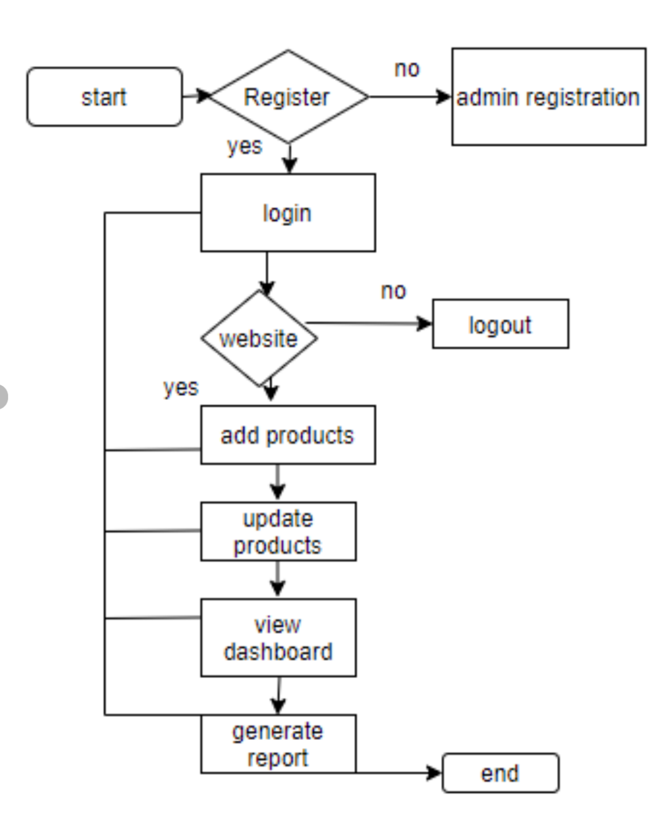
BLOCK DIAGRAM

Block diagrams serve as a visual tool to simplify complex systems, illustrating the relationships between components and facilitating communication among stakeholders. Above bock diagram is of e commerce website.

CONCLUSION
The developed e-commerce fashion website provides an efficient and user-friendly platform for online shopping. It helps customers purchase trendy clothes conveniently while enabling businesses to expand their reach digitally.

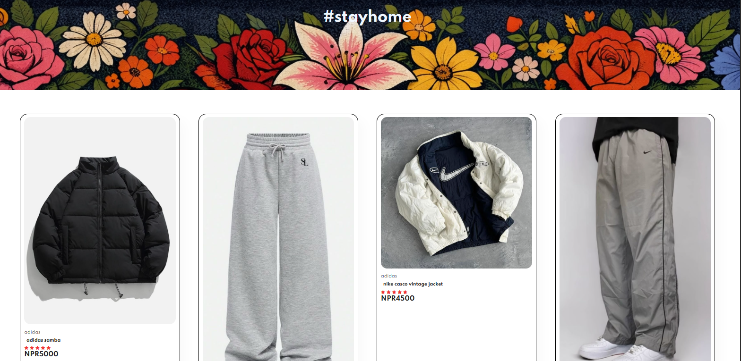

APPENDIX
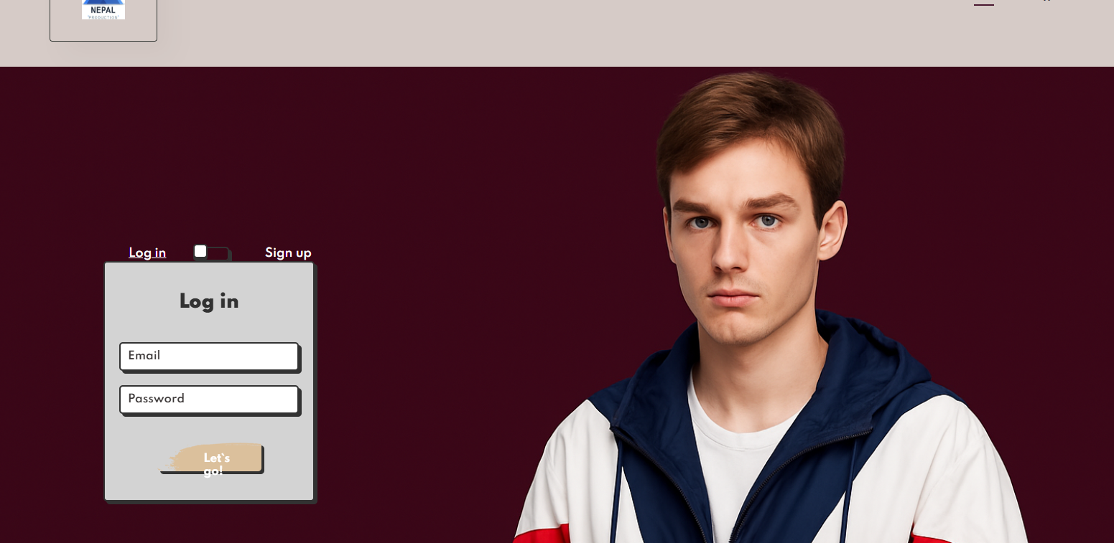

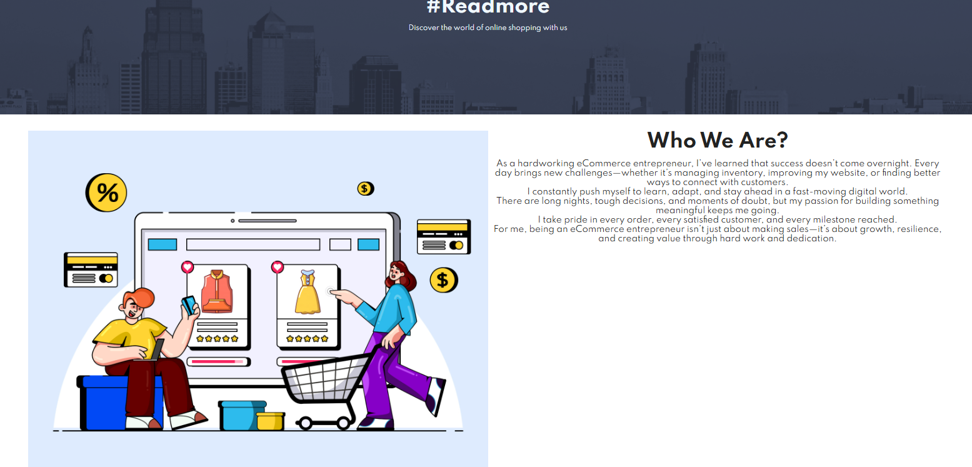

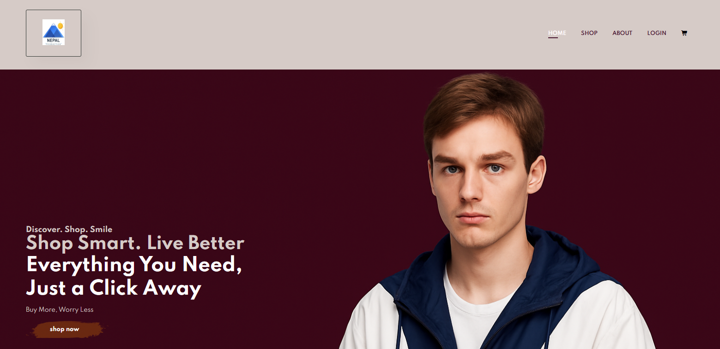

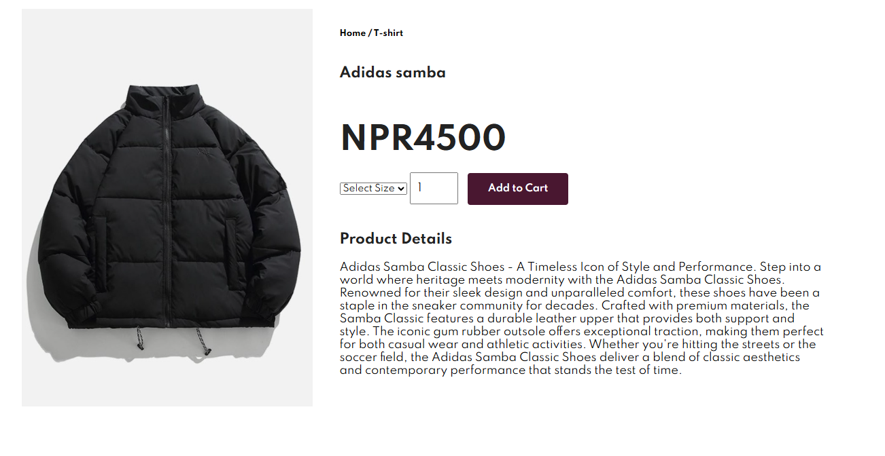

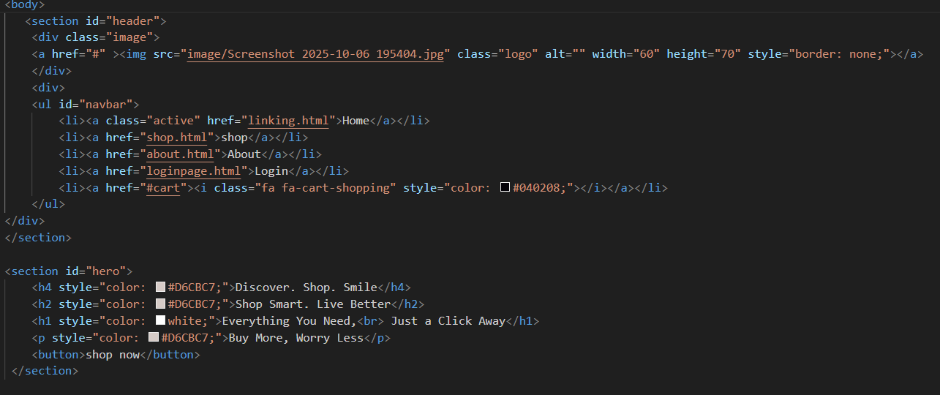
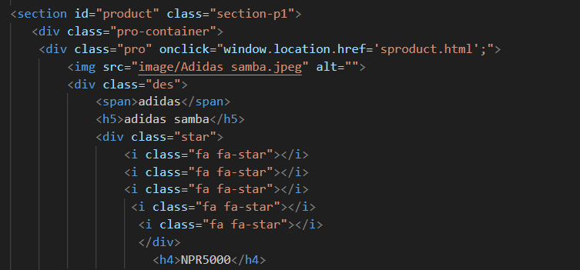
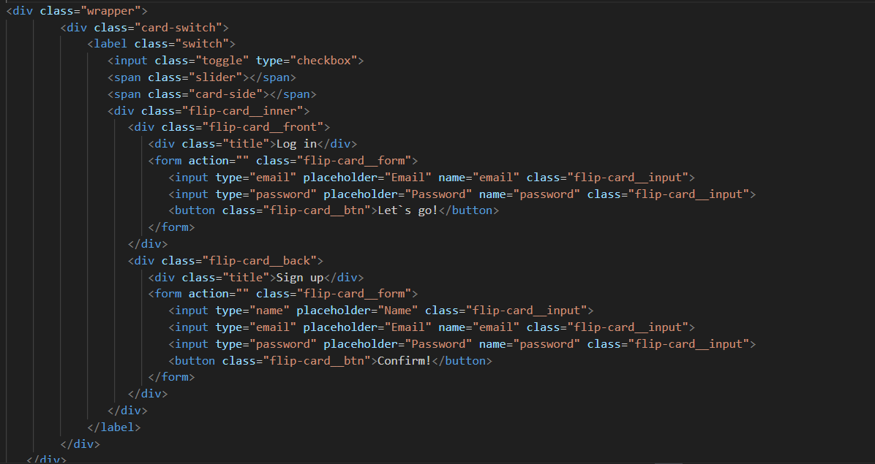
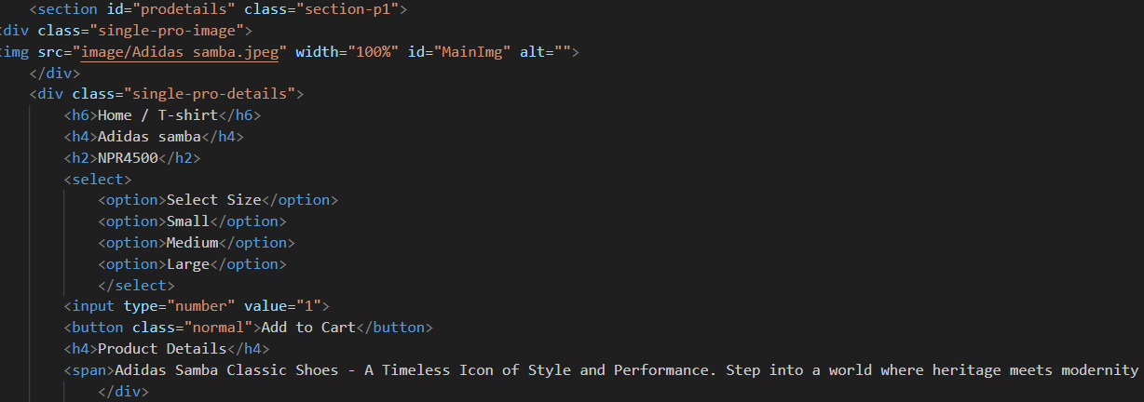
REFERENCE
- Java: The Complete Reference by Herbert Schildt.
- W3Schools.com (HTML/CSS Tutorials).
- Oracle Java Documentation (docs.oracle.com).

